Chesapeake Bay Report Card Activity

Grade level: 5 - 8

Introduction:

The Chesapeake Bay is the largest estuary in the United States and an important ecosystem that supports a wide range of plants and animals. Unfortunately, the health of the Chesapeake Bay has been declining due to pollution, habitat loss, and other factors. In this activity, students will create a report card to assess the health of the Chesapeake Bay and identify ways to improve its health.

Objectives:
- Understand the concept of environmental indicators and how they can be used to assess the health of an ecosystem.
- Collect and analyze data related to water quality, habitat, and other factors that affect the health of the Chesapeake Bay.
- Identify the stakeholders who are affected by the health of the Chesapeake Bay and consider their perspectives and needs.
- Develop recommendations for improving the health of the Chesapeake Bay based on the data and analysis.

Materials needed:

- Chesapeake Bay Report Card Worksheet
- Chesapeake Bay Map
- Water quality testing kit (optional)
- Field notebook and pen/pencil

Procedure
- Introduce the concept of environmental indicators and explain how they can be used to assess the health of an ecosystem. Give examples of environmental indicators, such as water quality, habitat, and biodiversity.

- Divide students into groups and give each group a Chesapeake Bay Report Card Worksheet and a Chesapeake Bay Map.
- Instruct students to collect data related to the following indicators:
- Water quality: Students can use a water quality testing kit (if available) to test the water for pH, dissolved oxygen, and other factors that affect water quality. Alternatively, students can research existing water quality data for the Chesapeake Bay.
- Habitat: Students can observe the habitat in and around the Chesapeake Bay and record their observations in their field notebooks. They can also research the types of habitats that are important for the plants and animals in the Chesapeake Bay.
- Biodiversity: Students can research the types of plants and animals that are found in the Chesapeake Bay and record their observations in their field notebooks.
- After collecting data, instruct students to analyze the data and assign scores to each indicator based on the strengths and weaknesses identified. The scores should be consistent with the data and analysis presented.
- Instruct students to identify the stakeholders who are affected by the health of the Chesapeake Bay, such as fishermen, farmers, and residents who live near the Bay. They should consider the perspectives and needs of each stakeholder group.
- Instruct students to develop recommendations for improving the health of the Chesapeake Bay based on the data and analysis. The recommendations should be specific, feasible, and based on the strengths and weaknesses identified.
- Instruct students to create a report card that presents the data, analysis, scores, and recommendations in a clear and visually appealing way. The report card should be designed for a general audience, such as the school community or the general public.
- Instruct students to present their report cards to the class and have a discussion about the findings and recommendations.

Assessment: Students will be assessed based on their ability to:
- Collect and analyze data related to the indicators.
- Assign scores to each indicator based on the strengths and weaknesses identified.
- Identify the stakeholders who are affected by the health of the Chesapeake Bay and consider their perspectives and needs.
- Develop recommendations for improving the health of the Chesapeake Bay based on the data and analysis.
- Create a clear and visually appealing report card that presents the data, analysis, scores, and recommendations.
- Participate in the class discussion about the findings and recommendations.

Map & worksheet on following page…

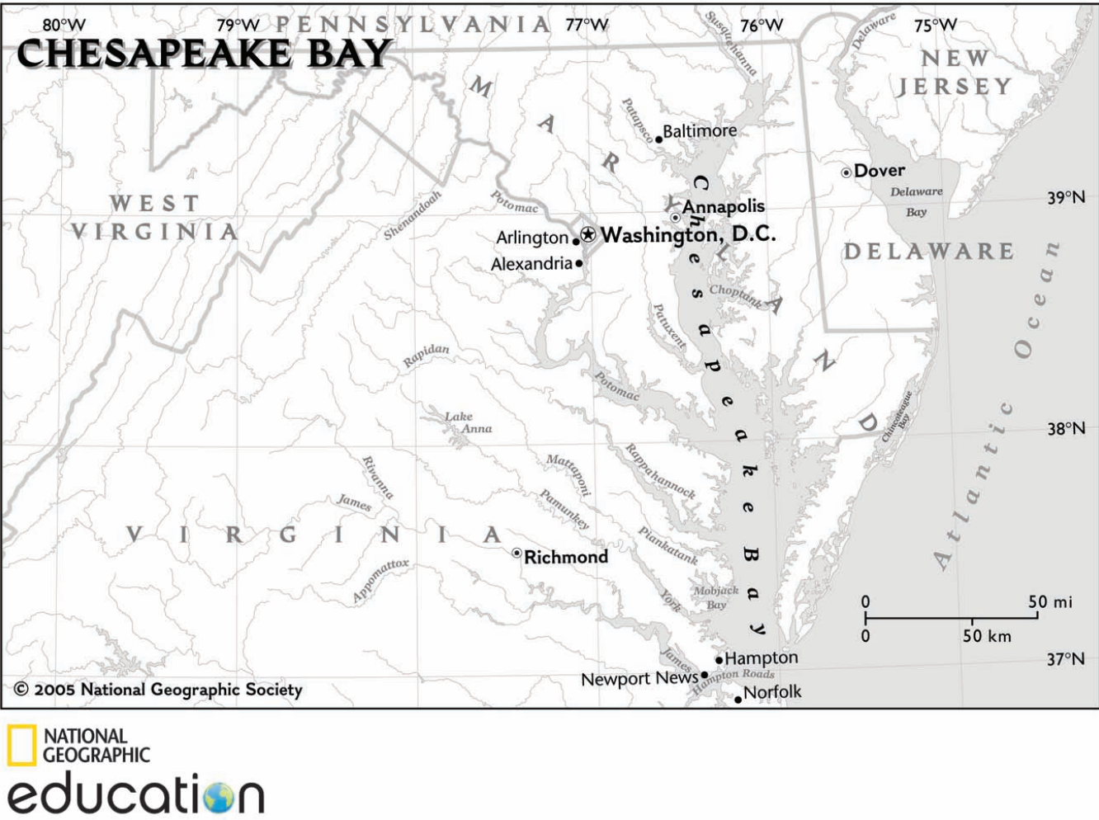

Chesapeake Bay Report Card Worksheet
Indicator | Strengths | Weaknesses
Water Quality
Habitat
Biodiversity

